Module-1
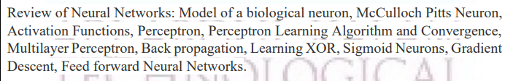
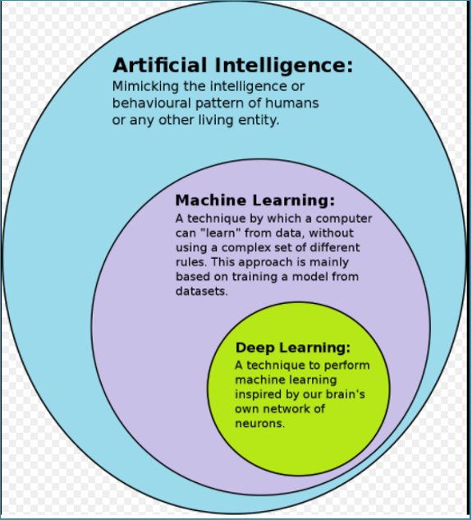
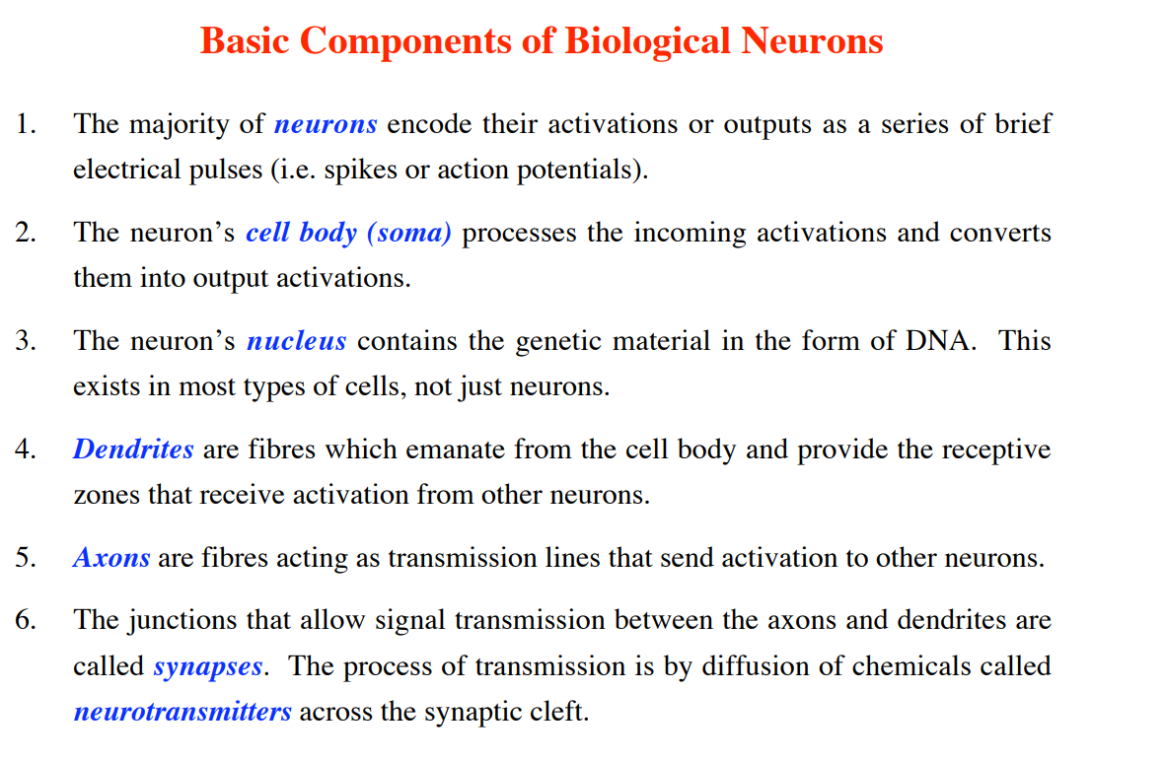
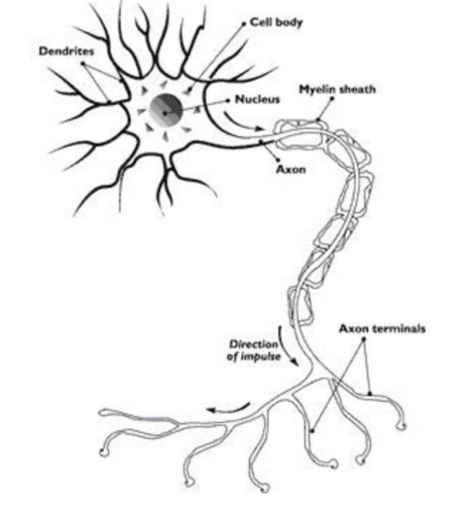
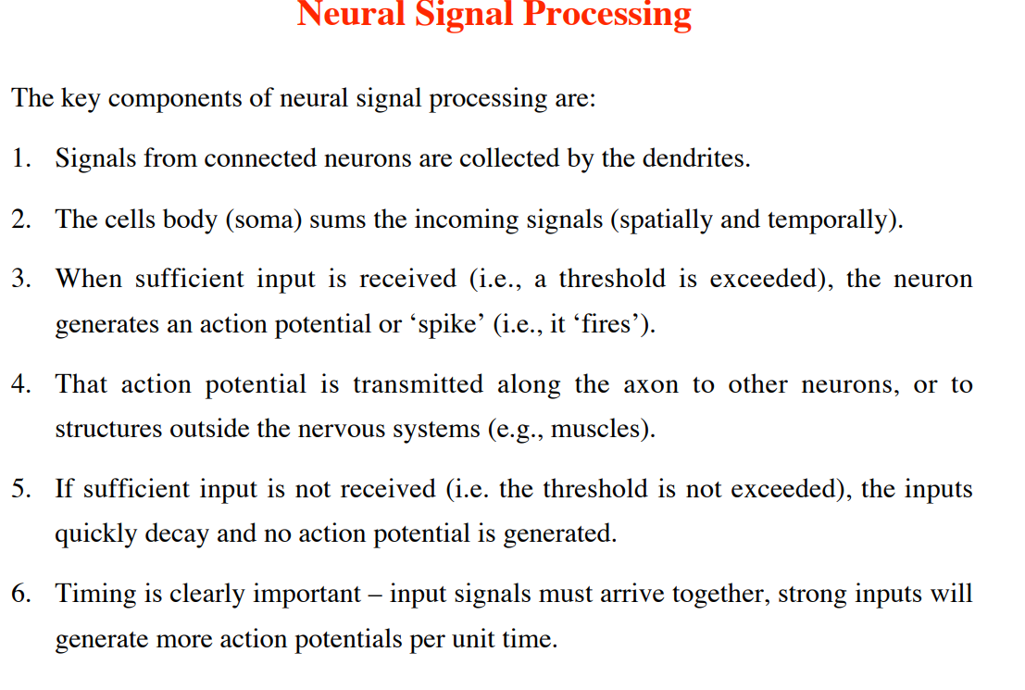

Artificial Neural Network
Artificial Neural Network ANNANN is an efficient computing system whose central theme is borrowed from the analogy of biological neural networks. ANNs are also named as “artificial neural systems,” or “parallel distributed processing systems,” or “connectionist systems.” ANN acquires a large collection of units that are interconnected in some pattern to allow communication between the units. These units, also referred to as nodes or neurons, are simple processors which operate in parallel.
Every neuron is connected with other neuron through a connection link. Each connection link is associated with a weight that has information about the input signal. This is the most useful information for neurons to solve a particular problem because the weight usually excites or inhibits the signal that is being communicated. Each neuron has an internal state, which is called an activation signal. Output signals, which are produced after combining the input signals and activation rule, may be sent to other units.

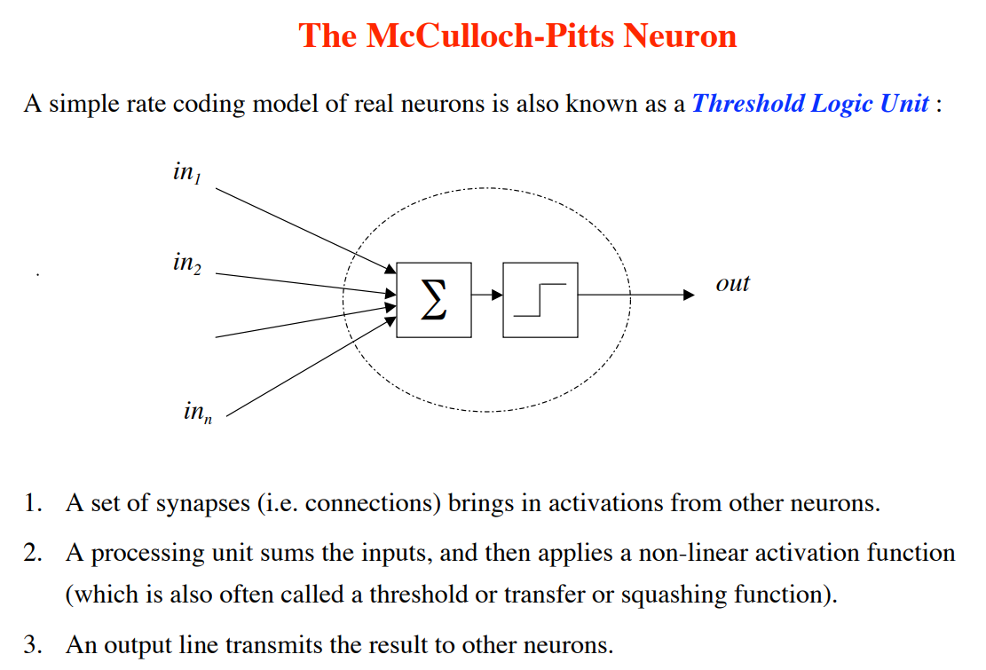

ANN versus BNN
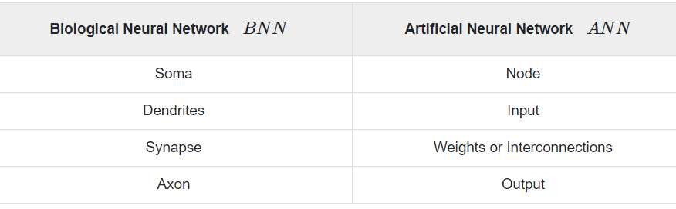

Model of Artificial Neural Network
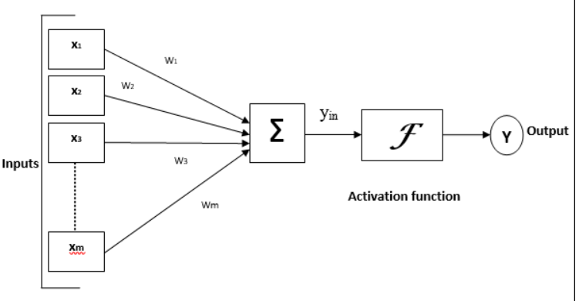
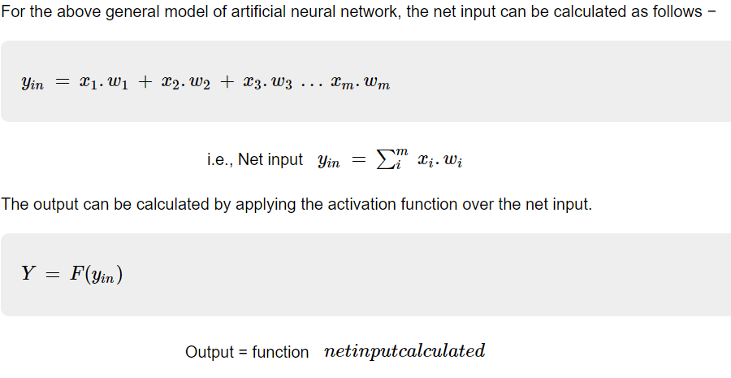

Artificial Neural Network - Building Blocks
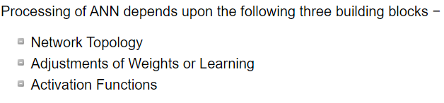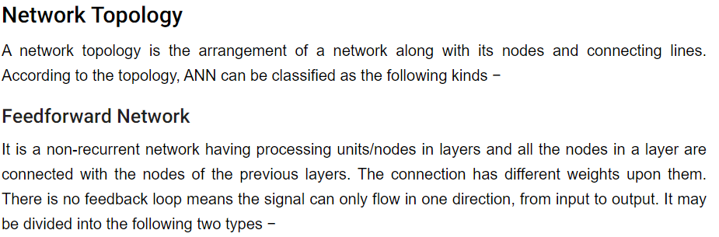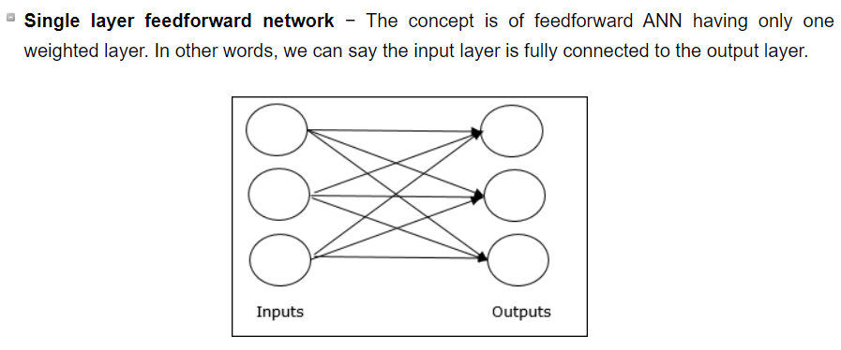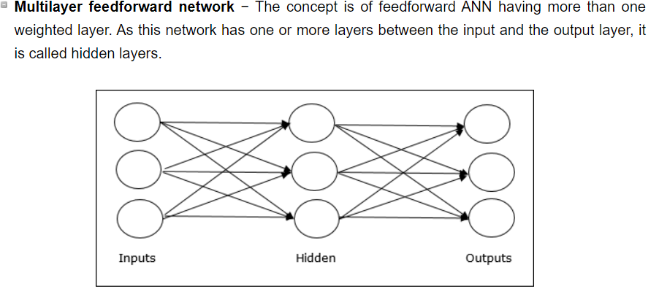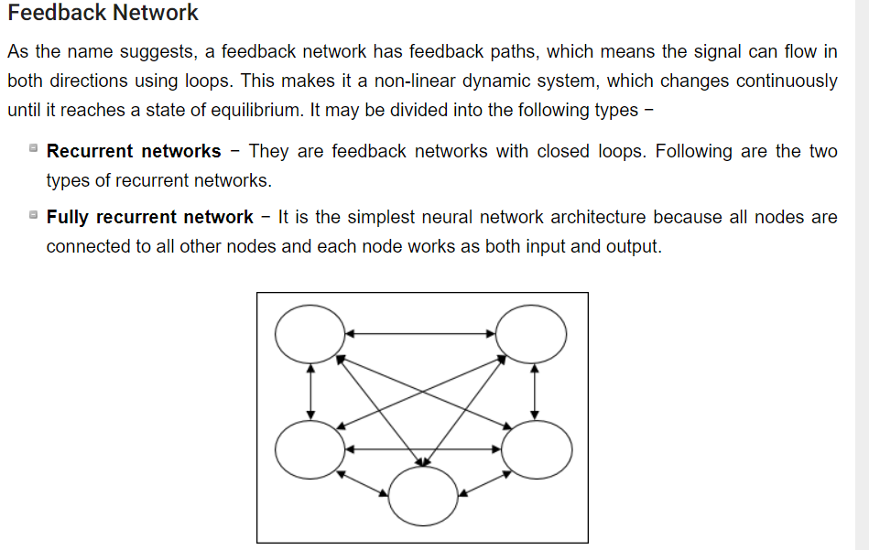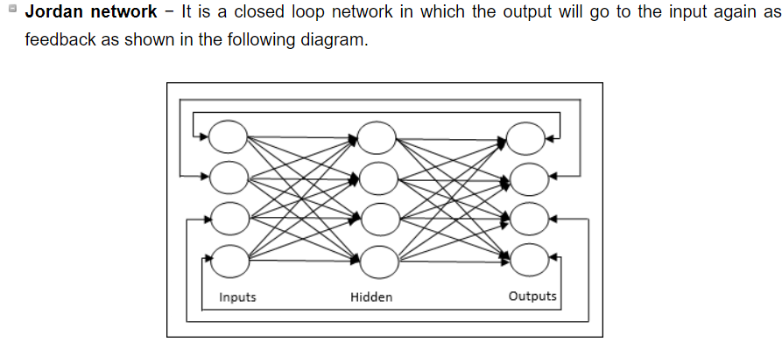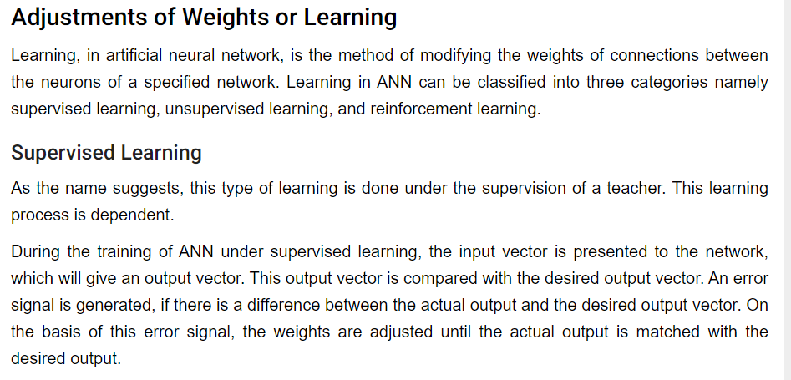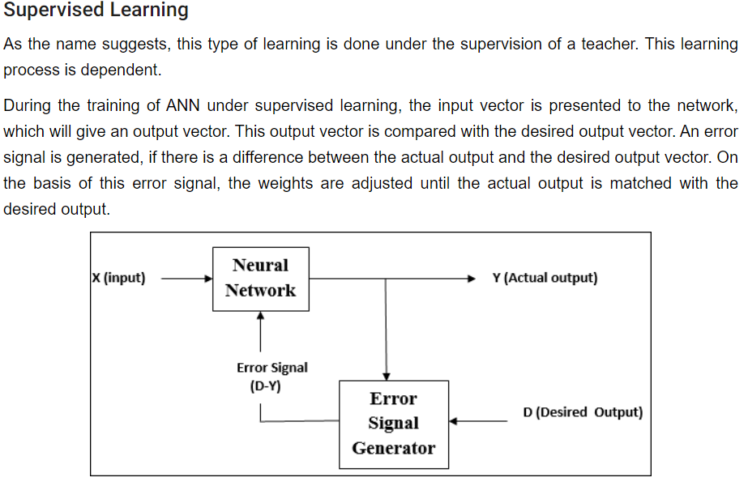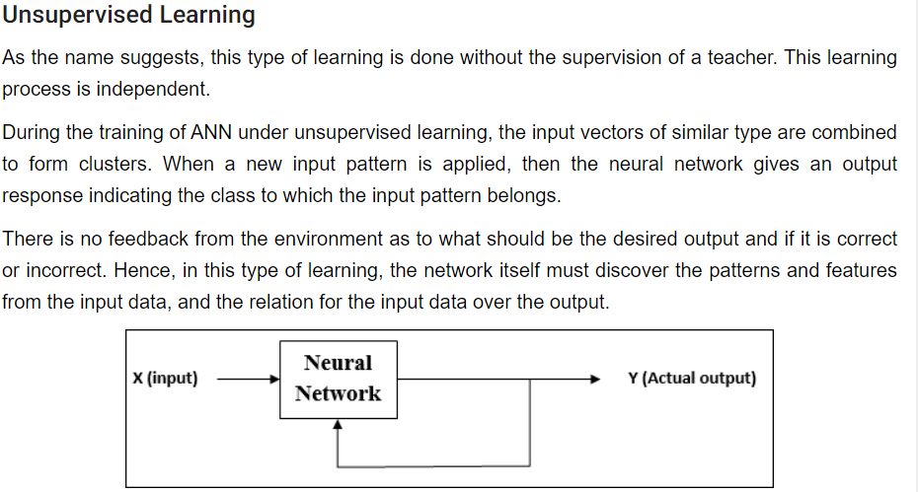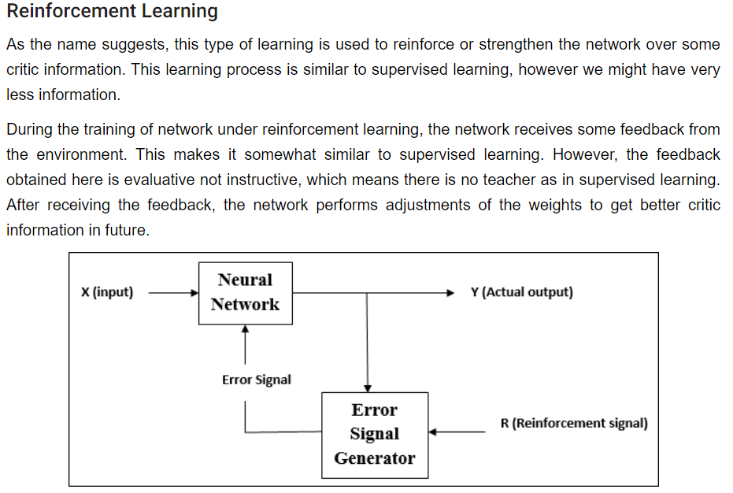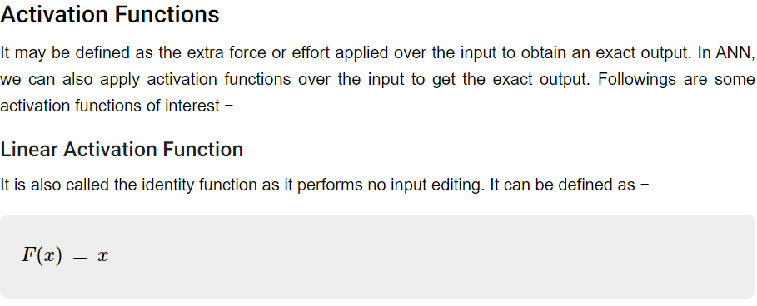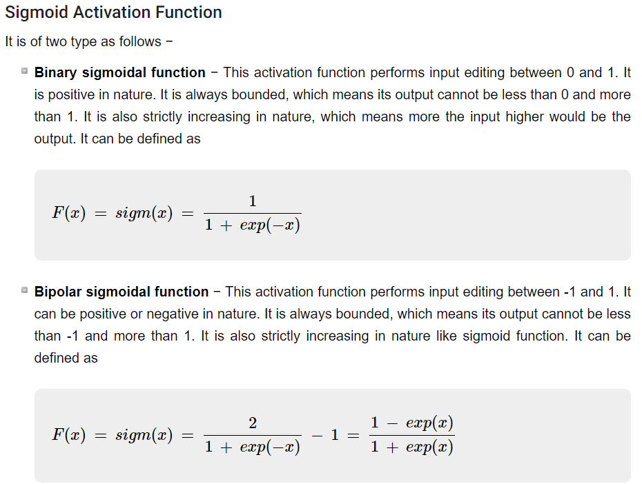

Back Propagation Neural Networks

Back Propagation Neural (BPN) is a multilayer neural network consisting of the input layer, at least one hidden layer and output layer. As its name suggests, back propagating will take place in this network. The error which is calculated at the output layer, by comparing the target output and the actual output, will be propagated back towards the input layer.

Architecture
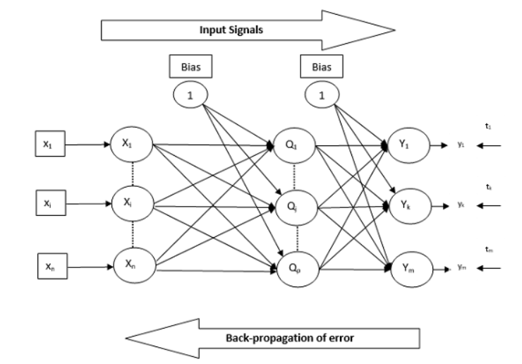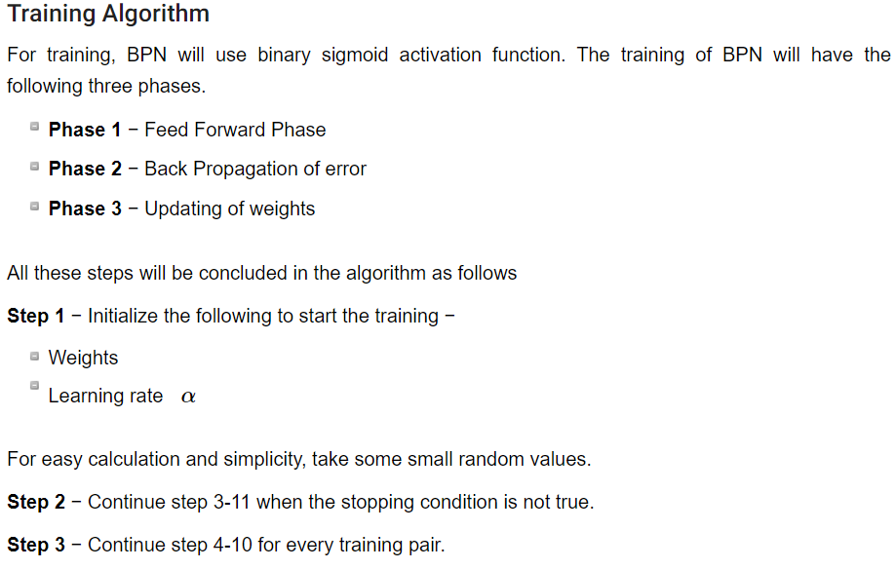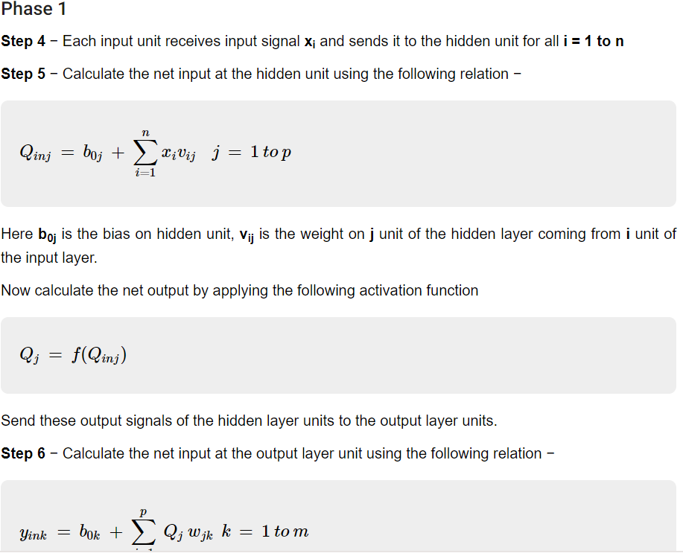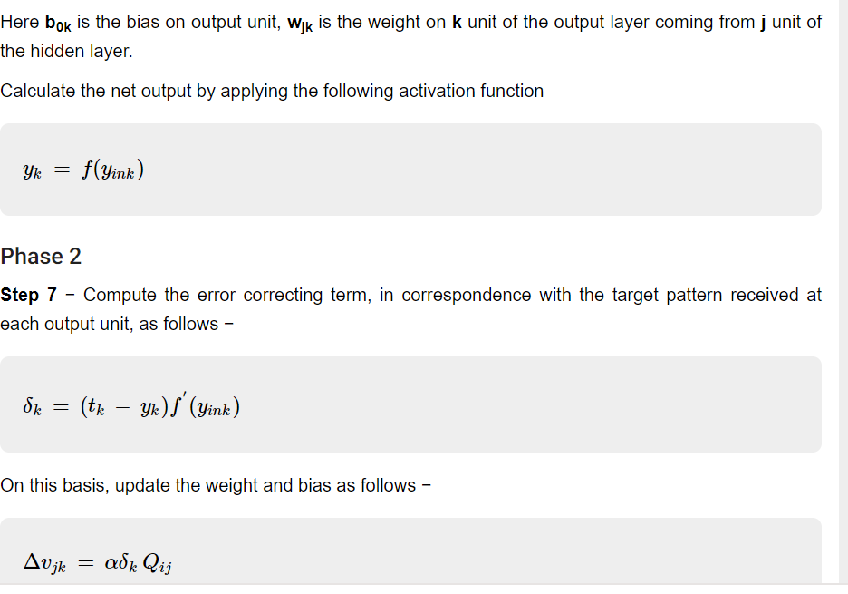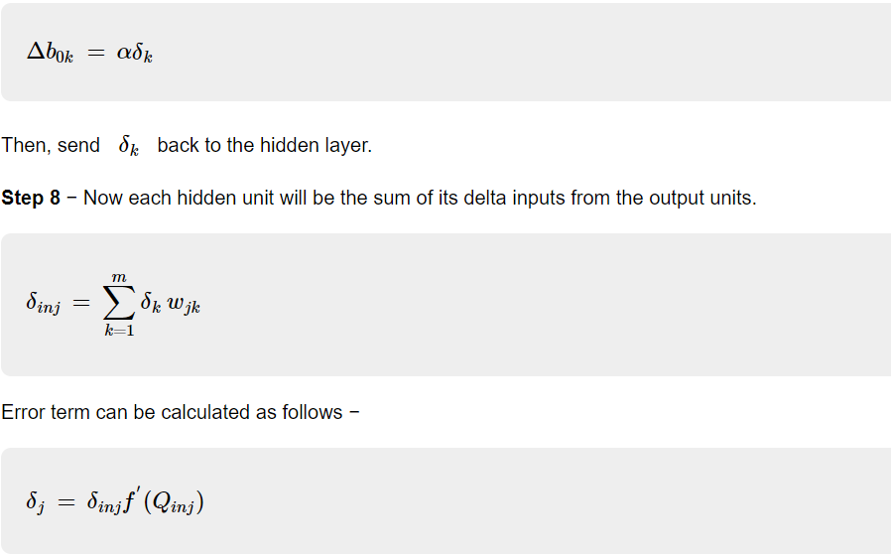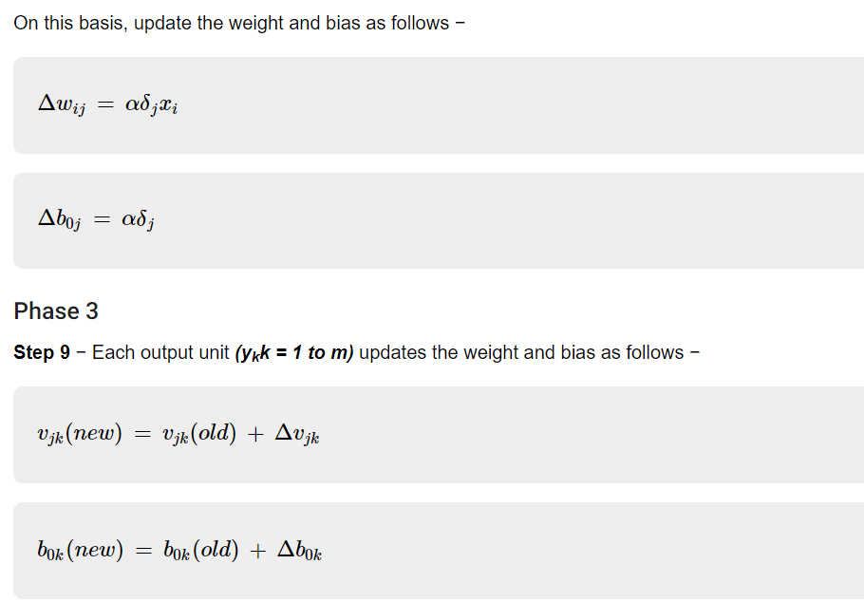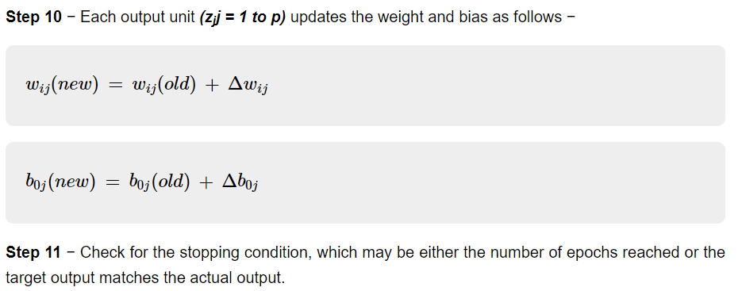

Perceptron
Perceptron is a building block of an Artificial Neural Network.
Mr. Frank Rosenblatt invented the Perceptron for performing certain calculations to detect input data capabilities or business intelligence. Perceptron is a linear Machine Learning algorithm used for supervised learning for various binary classifiers. This algorithm enables neurons to learn elements and processes them one by one during preparation. 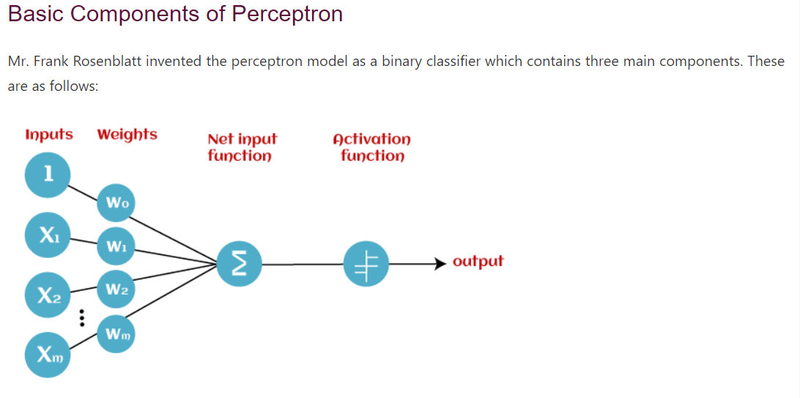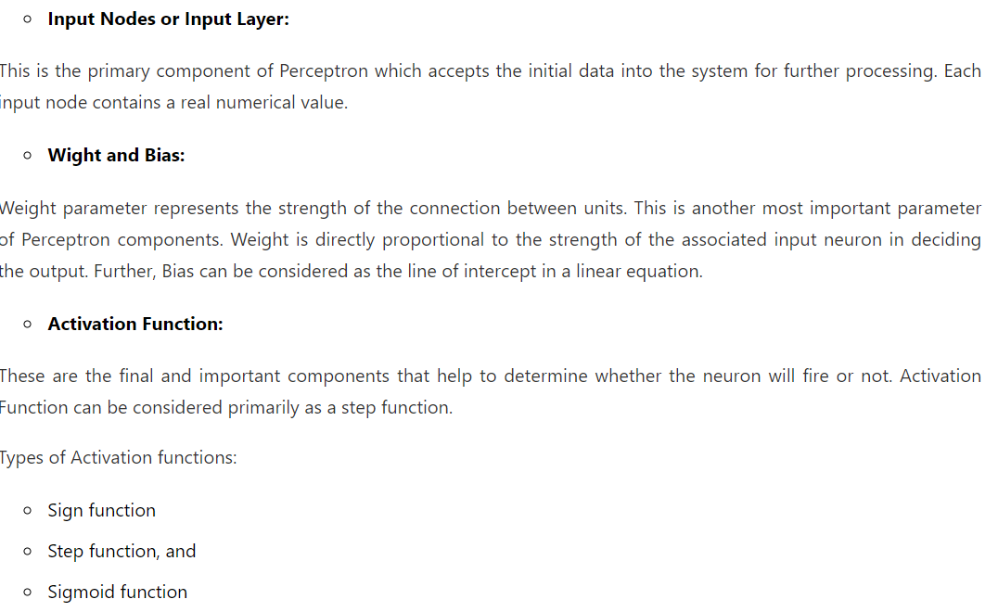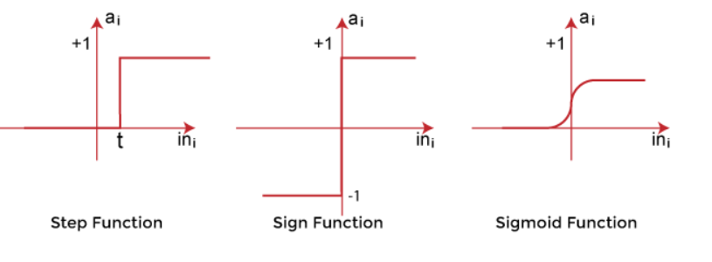
Working of perceptron
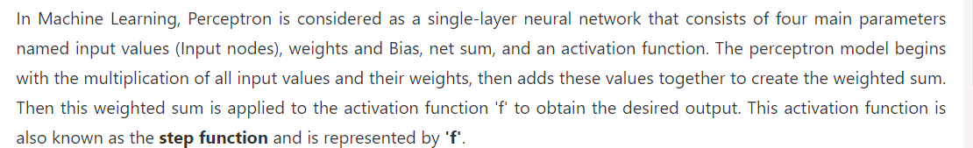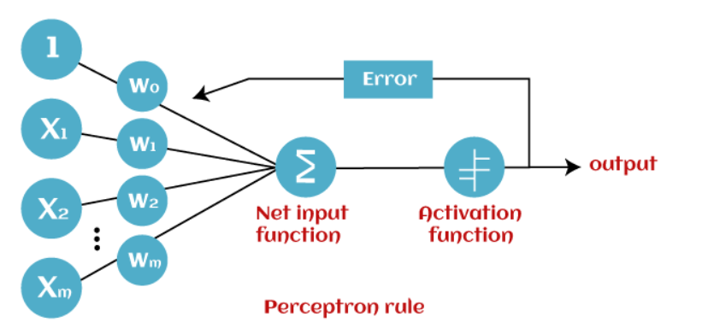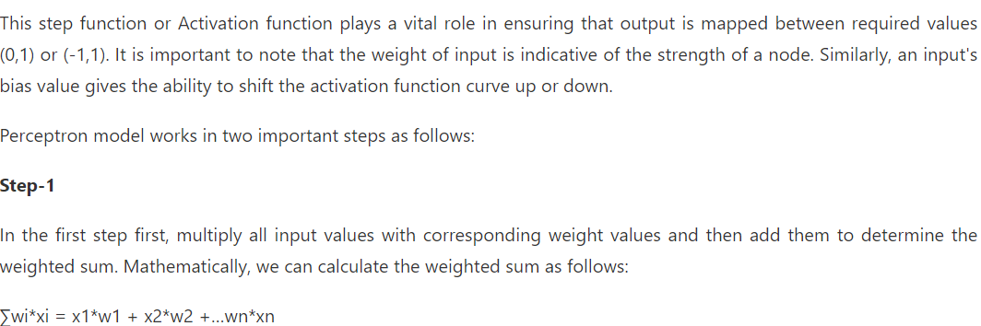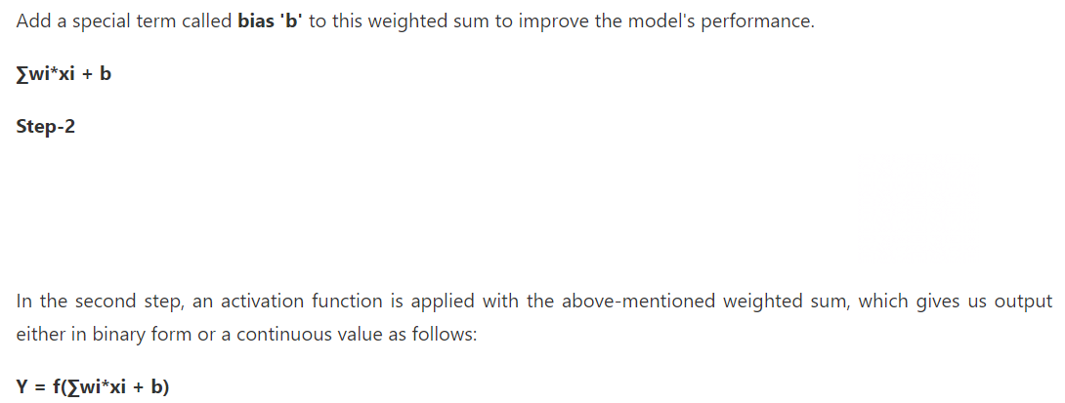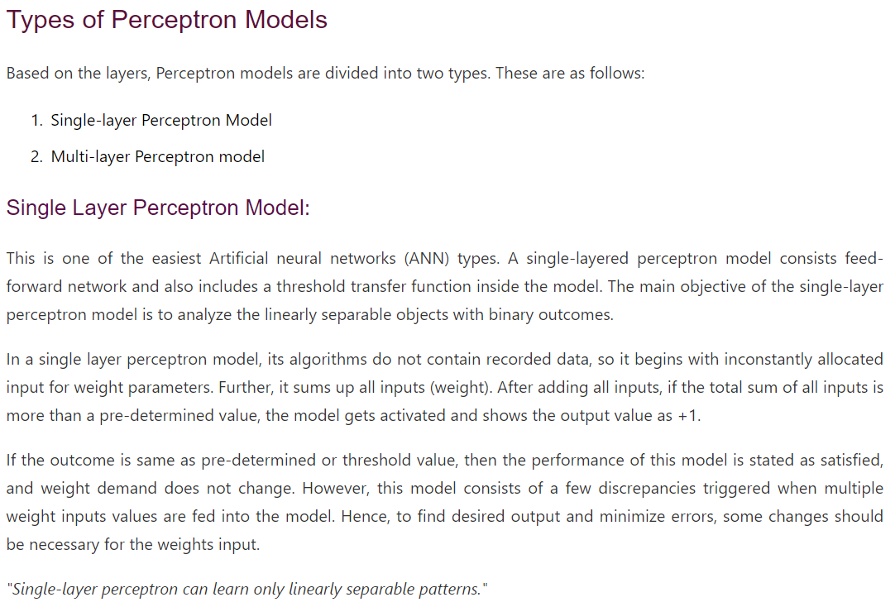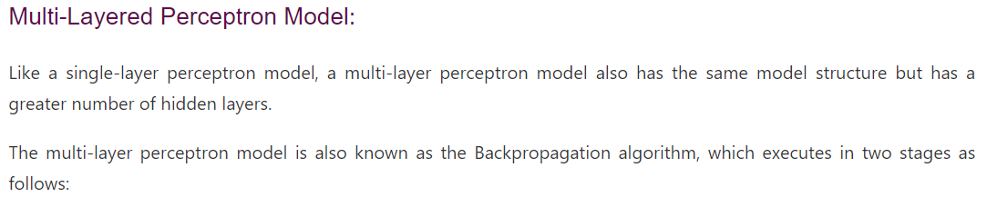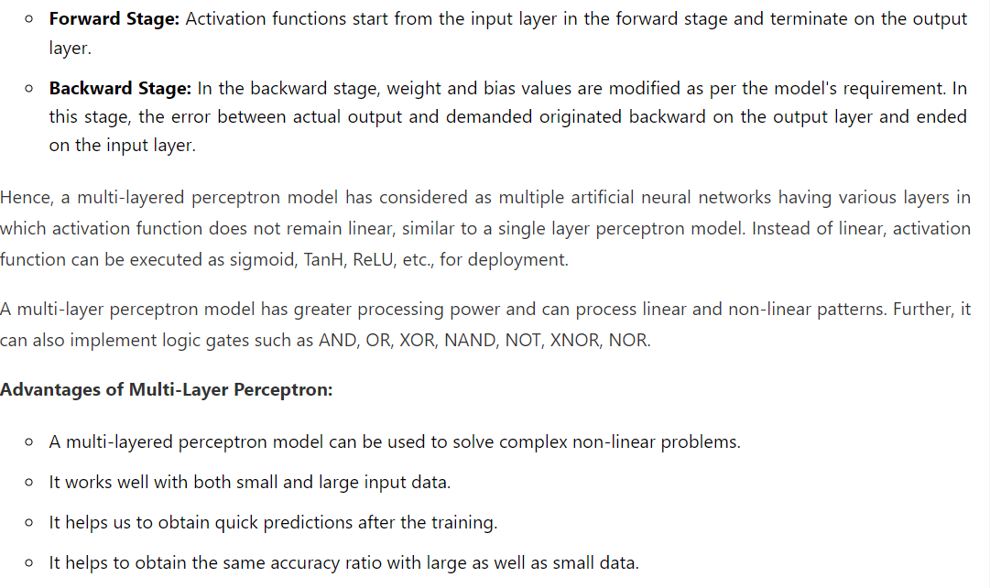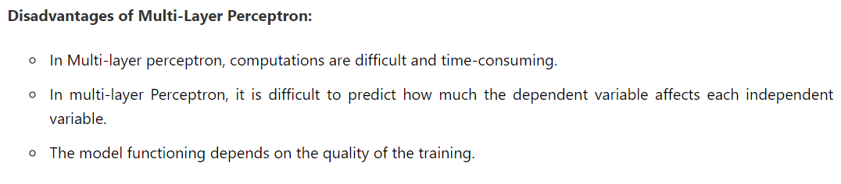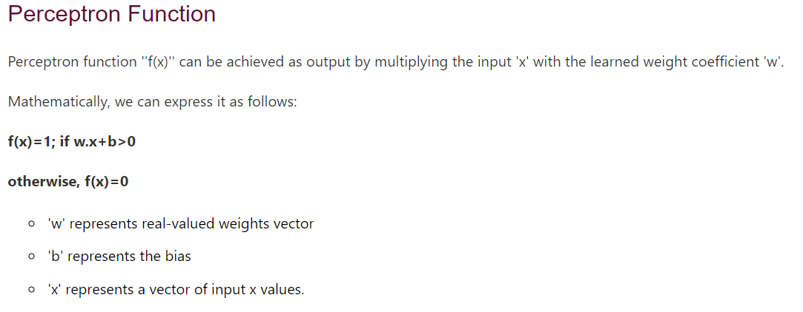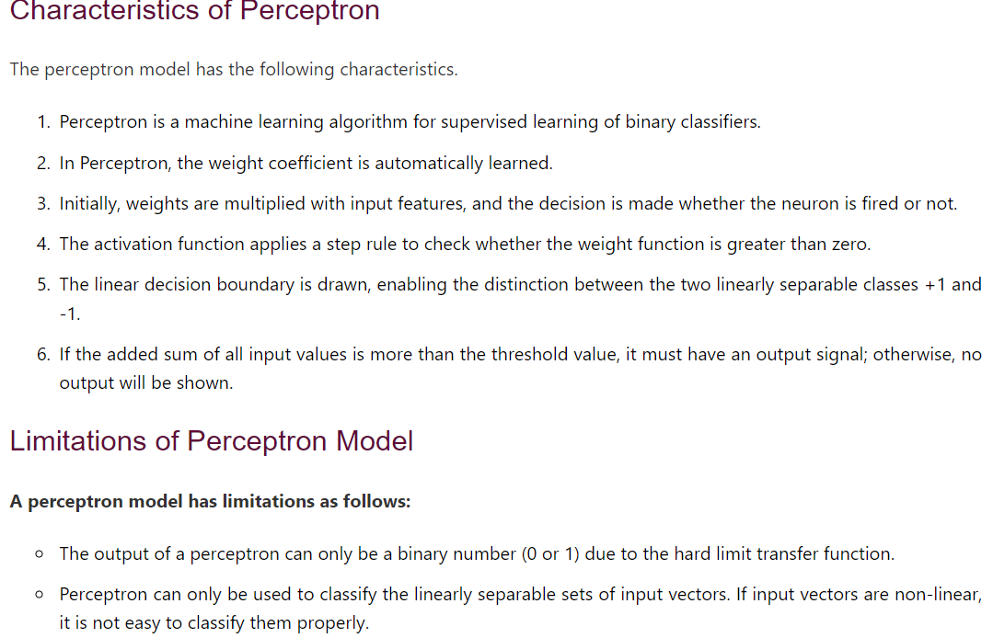Perceptron Learning Algorithm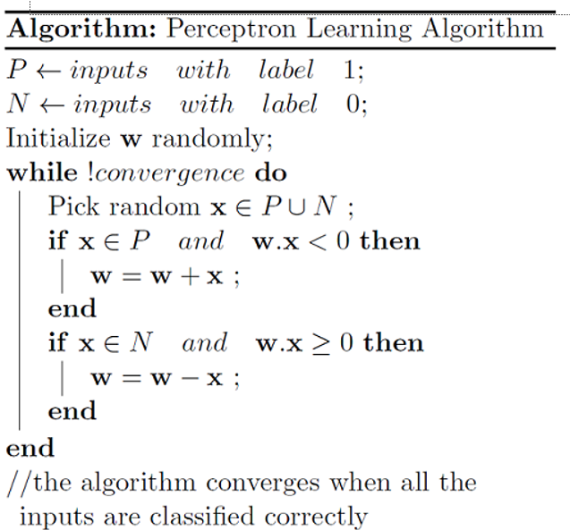Gradient Descent Algorithm
Gradient Descent Algorithm iteratively calculates the next point using gradient at the current position, then scales it (by a learning rate) and subtracts obtained value from the current position (makes a step). It subtracts the value because we want to minimise the function (to maximise it would be adding).
- There’s an important parameter η which scales the gradient and thus controls the step size. In machine learning, it is called learning rate and have a strong influence on performance.
- The smaller learning rate the longer GD converges, or may reach maximum iteration before reaching the optimum point
- If learning rate is too big the algorithm may not converge to the optimal point (jump around) or even to diverge completely.
Gradient Descent method’s steps are: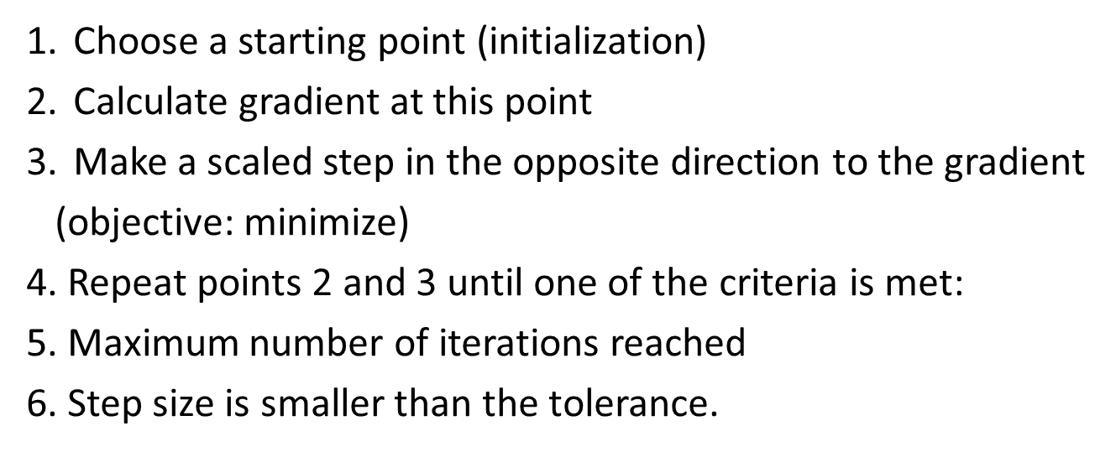

Backpropagation Process in Deep Neural Network
Backpropagation is one of the important concepts of a neural network. Our task is to classify our data best. For this, we have to update the weights of parameter and bias. we also use gradient descent algorithm using Backpropagation. For a single training example, Backpropagation algorithm calculates the gradient of the error function. Backpropagation can be written as a function of the neural network. Backpropagation algorithms are a set of methods used to efficiently train artificial neural networks following a gradient descent approach which exploits the chain rule.
The main features of Backpropagation are the iterative, recursive and efficient method through which it calculates the updated weight to improve the network until it is not able to perform the task for which it is being trained. Derivatives of the activation function to be known at network design time is required to Backpropagation.
Eg: 

